1980 CITATION II
Serial Number 550-0104 Registration CC-CLC

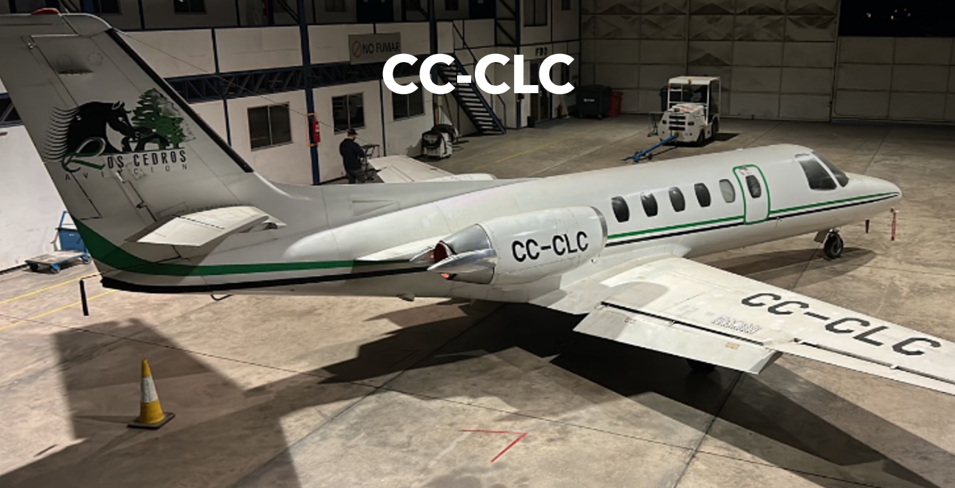

AIRFRAME:
14457,8 Total Hours 9472 Landings

ENGINES: JT15D-4 3500 TBO
Left Serial Number PCE70910 Right Serial Number PCE70174
7247,7 Hours Total Time 8778,5 Hours Total Time
5832 Cycles 7062 Cycles
3187,3 Hours Remaining Until Overhaul (HRUO) 1252,7 Hours Remaining Until Overhaul (HRUO)

AVAILABLE IMMEDIATELY, MAKE OFFER
Maria Eckardt WhatsApp/Cell: +1 941-586-2054 maria@flighsource.com
Samir Hiweg WhatsApp/Cell: +593 982-387-453 samir@mundiaereo.com
Samir Hiweg WhatsApp/Cell: +593 961-961-100 samir@flightsource.com

AVIONICS:

ADF: | Dual Collins ADF-60A
Altimeter: | Dual (1 encoding)
Autopilot: | Sperry SPZ-500 IFCS
Communication Radios: | Dual Collins VHF-20
Compass: | Dual Sperry C-14D
CVR: | Fairchild A100A
DME: | Dual Collins DME-42
Flight Director: | Sperry MS-205
Flight Rules: | IFR
FMS: | Universal UNS-1K w/GPS
GPS: | No
Navigation Radios: | Dual Collins VIR-30
Radar Altimeter: | Sperry AA-215
RMI: | Dual Collins
TAWS: | No
Transponder: | Dual Collins TDR-90
Weather Radar: | Honeywell RT-131A

ADDITIONAL:
Cockpit: | ELT, angle of attack indicator
Equipment: | Thrust reversers, anti-skid brakes, Branson gross weight increase mod, aft baggage mod, zero fuel weight increase mod

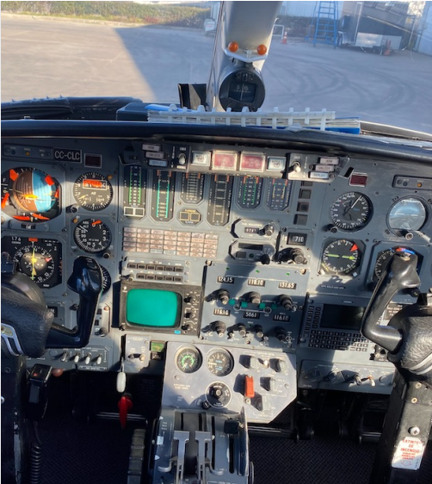

INTERIOR:

Configuration/PAX: | Executive/11 passengers
Air Conditioning: | No
General: | Bravo-style interior
Seating: | Bravo-style grey leather double club seating w/taupe inserts & matching arm rests
Headliner: | Sahara Sands beige headliner
Sidewalls: | Sahara Sands beige upper sidepanels, almond lower sidepanels
Carpet: | Almond carpeting
Refreshment : | Forward Slimline refreshment center, mid-cabin Pyramid cabinet
Cabinetry/Wood: | Hide-away executive work tables
Lavatory: | Belted aft lav

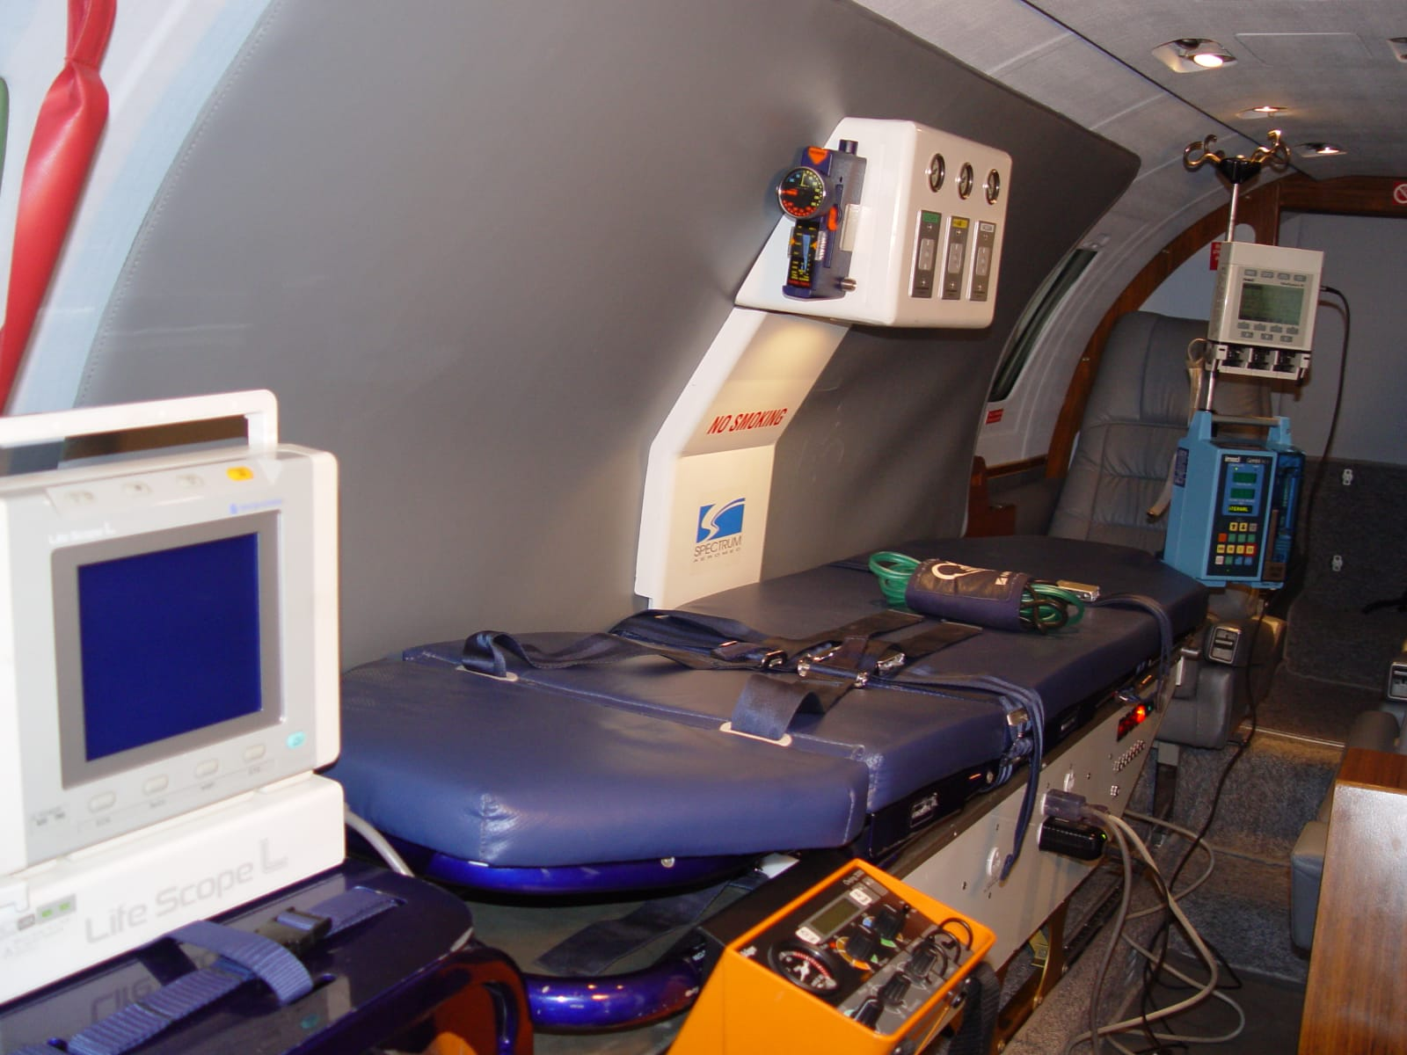

AVAILABLE IMMEDIATELY, Call Maria +1 941-586-2054 maria@flightsource.com

Samir Hiweg +593 961-961-100 samir@mundiaereo.com / samir@flightsource.com

EXTERIOR:
Colors: | High-gloss Matterhorn white w/green & black stripes

MAINTENANCE:
Maintained: | FAR Part 135
Airframe Maint Program: | Cessna MM ATA 04 & 05
Airframe Tracking Program: | Unknown
Certification(s): | RVSM
Weights/Capacity: | WEIGHTS (lbs.): RAMP 13500, MTOW 13300, LANDING 12700, ZFW 9500, EMPTY 8247, FUEL 4971. FUEL CAPACITY: 742 U.S. gallons., WEIGHTS (kgs.): RAMP 6122, MTOW 6033, LANDING 5759, ZFW 4309, EMPTY 3741, FUEL 2255. FUEL CAPACITY: 2809 liters.

ITEMS | C/W | DUE
Phase 10 Inspection: | 14457,8 | May 2025
Phase B Inspection: | 14442,4 | 14592,4
Phase 57 Inspection: | On condition | N/A
Phase 11 Inspection: | SB550-22-06 | N/A
Phase 58 Inspection: | N/A not installed | N/A
Phase 61 Inspection: | 12 DEC 23 | 11 JUN 24
Right Engine Hot Section Inspection:
Phase 1 Inspection: | 14442,4 – 05 MAR 23 | 14472,4 – 04 MAR 25
Phase 2 Inspection: | 14442,4 – 05 MAR 23 | 14472,4 – 04 MAR 25
Phase 3 Inspection: | 14442,4 – 05 MAR 23 | 14472,4 – 04 MAR 25
Phase 4 Inspection: | 14442,4 – 05 MAR 23 | 14472,4 – 04 MAR 25
Phase 18 Inspection: | MAY 24 | MAY 25
Phase 34 Inspection: | MAY 24 | NOV 25
Document MA Inspection:
RVSM: | 13492,1 | 14492,1
Certificate of Airworthiness: | 19 OCT 22 | 17 OCT 26
Date of Manufacture: | 1980

AVAILABLE IMMEDIATELY, MAKE OFFER
Maria Eckardt WhatsApp/Cell: +1 941-586-2054 maria@flighsource.com
Samir Hiweg WhatsApp/Cell: +593 982-387-453 samir@mundiaereo.com
Samir Hiweg WhatsApp/Cell: +593 961-961-100 samir@flightsource.com

