1981 Beechcraft King Air F90
Serial Number LA-140
Registration HC-CJC
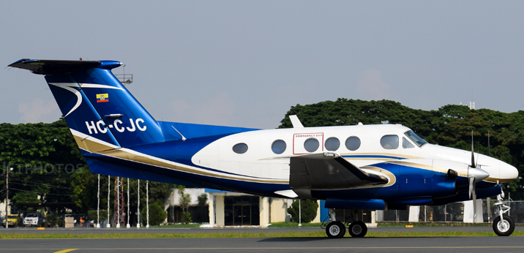

Description:
Location: GYE/SEGU/Jose Joaquin de Olmedo Airport, Guayaquil – Ecuador.
AirframeTotal Time:
14319,3
Engine #1/Make/Model:
PRATT & WHITNEY PT6A-135
Serial Number: PCE-92624
2721,2 SOH
Engine 1 TBO: 3,600
SOH (12/04 – Dallas Airmotive)
Engine #2/Make/Model:
PRATT & WHITNEY PT6A-135
Serial Number: PCE-92634
3018,0 SOH
Engine 2 TBO: 3,600
SOH (12/04 – Dallas Airmotive)

Prop #1/Make/Model:
Prop 1 Serial Number: EAA1665
HARTZELL/4 Blades
Prop 1 Overhaul Time: 455,7
TBO: 3,000
Prop #2/Make/Model:
Prop 2 Serial Number: CDA3356
HARTZELL/4 Blades
Prop 2 Overhaul Time: 455,7
TBO: 3,000

Avionics:
Avionics/Radios
Autopilot: Sperry SPZ-200A IFCS
Comms: Garmin GNS-430 & GNS-750
Radar: King RDR-1300 color
DME: King KDM-706
Navs: Dual King KNR
Flight Director: Sperry SPZ-200A IFCS
GPS: Garmin GNS750 (IFR certified)
Transponder: Dual King KXP-755 & Garmin
GPS: Garmin 600
Avidyne Flight Max EX-500
Avidyne Moving Map
Additional Equipment:
Prop Auto Feather
Cleveland Wheels & Brakes
Fourth Cabin Window
Pressurized Cabin
VFR/IFR Certified
Exterior:
Year Painted2020
Overall White with Blue and Gold Stripes.
Interior:
Year Interior2020
Executive Seating for 6 in Tan Leather Matching Side Panels & Carpeting. Refreshment Equipped MAPCO & Water Dispenser, Veneer Cabinetry with Dual Executive Writing Tables, Aft Lavatory.
Inspection/MX Status:
Up to Date, Available Upon Request

AVAILABLE IMMEDIATELY, Call Maria +1 941-586-2054 maria@flightsource.com

Samir Hiweg +593 961-961-100 samir@mundiaereo.com / samir@flightsource.com

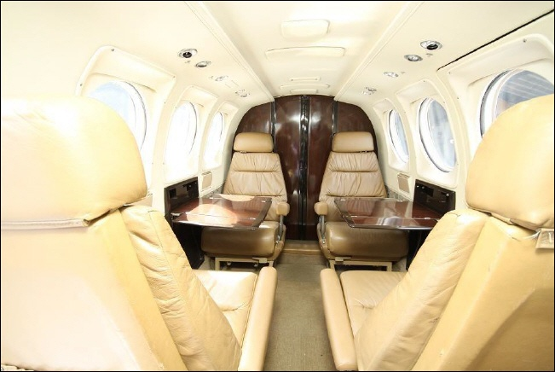

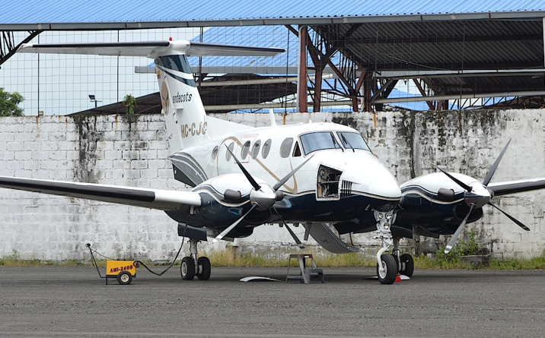

AVAILABLE IMMEDIATELY, Call Maria +1 941-586-2054 maria@flightsource.com

Samir Hiweg +593 961-961-100 samir@mundiaereo.com / samir@flightsource.com

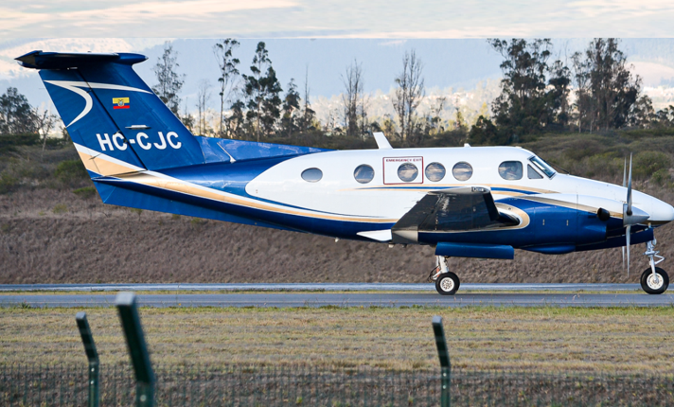

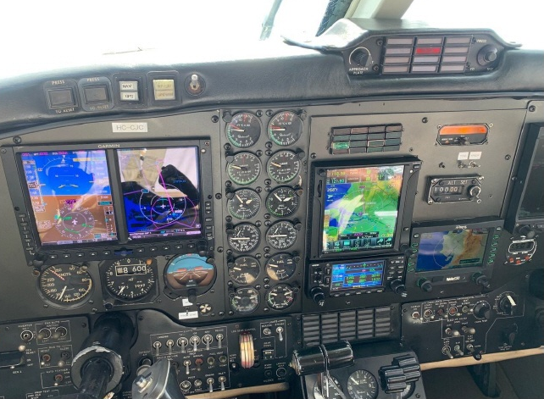

AVAILABLE IMMEDIATELY, Call Maria +1 941-586-2054 maria@flightsource.com

Samir Hiweg +593 961-961-100 samir@mundiaereo.com / samir@flightsource.com

