1982 Cessna 172P

Serial Number 172-75440
Registration HC-BKA
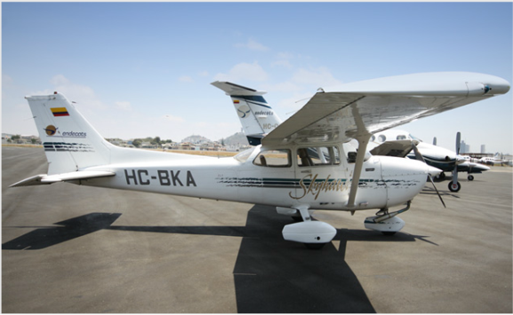

Description:
Location: GYE/SEGU/Jose Joaquin de Olmedo Airport, Guayaquil – Ecuador.
AirframeTotal Time:
14529
Engine #1/Make/Model:( monomotor)
LYCOMING O-320-D2J
Serial Number: N/A
404,2 SOH
Engine 1 TBO: 2000

AVAILABLE IMMEDIATELY, Call Maria +1 941-586-2054 maria@flightsource.com

Samir Hiweg +593 961-961-100 samir@mundiaereo.com / samir@flightsource.com

Prop #1/Make/Model: ( monomotor)

Prop 1 Serial Number: N/A
MC-CAULEY 1C160/DTM7557
Prop 1 Overhaul Time: 404,2
TBO: N/A

Avionics:
Comms: ADF / VOR / ILS /GPS 196 GARMIN
Additional Equipment:
N/A
Exterior:
Overall White with Black, Green and Gold Stripes.
Interior:
Executive Seating for 3 in Tan Leather Matching Side Panels & Carpeting.
Inspection/MX Status:
Up to Date, Available Upon Request

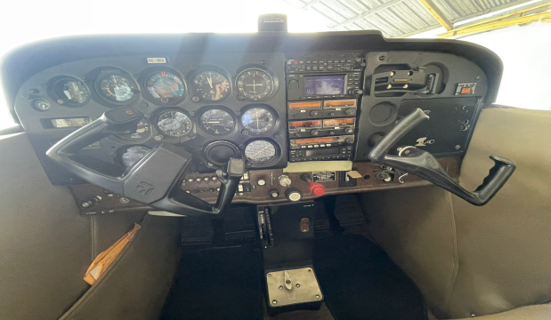

AVAILABLE IMMEDIATELY, Call Maria +1 941-586-2054 maria@flightsource.com

Samir Hiweg +593 961-961-100 samir@mundiaereo.com / samir@flightsource.com

Notes:
- The aircraft complies with the standards and maintenance programs imposed by the DGAC and by the manufacturer.
- The company has its own workshop in its installation; in which the stipulated MTTO is carried out.
- Both aircraft and pilots are available 24 hours and 365 days a year.
- The company has a stock of spare parts which allows it to solve basic needs before the maintenance requirement

AVAILABLE IMMEDIATELY, MAKE OFFER

Flight Source International, Inc: +1 941-355-9585 sales@flighsource.com
Maria Eckardt WhatsApp/Cell: +1 941-586-2054 maria@flighsource.com
Samir Hiweg WhatsApp/Cell: +593 982-387-453 samir@mundiaereo.com
Samir Hiweg WhatsApp/Cell: +593 961-961-100 samir@flightsource.com

