1979 Piper Seneca PA-34-200T

Serial Number 34-7970509
Registration HC-BNG
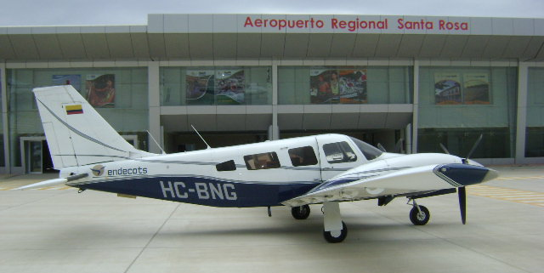

Description:
Location: GYE/SEGU/Jose Joaquin de Olmedo Airport, Guayaquil – Ecuador.
AirframeTotal Time:
10740,9
Engine #1/Make/Model:
CONTINENTAL TSIO-360EB / LTSIO-360EB
Serial Number: N/A
1159 SOH
Engine 1 TBO: 1800

AVAILABLE IMMEDIATELY, Call Maria +1 941-586-2054 maria@flightsource.com

Samir Hiweg +593 961-961-100 samir@mundiaereo.com / samir@flightsource.com
Engine #2/Make/Model:

CONTINENTAL TSIO-360EB / LTSIO-360EB
Serial Number: N/A
1159 SOH
Engine 1 TBO: 1800

Prop #1/Make/Model:

Prop 1 Serial Number: EB-4531-A
MC-CAULEY
Prop 1 Overhaul Time: 1319,10
TBO: 1800
Prop #2/Make/Model:

Prop 2 Serial Number: 786967
MC-CAULEY
Prop 2 Overhaul Time: 1319,10
TBO: 1800

Avionics:

Comms: / VOR / ILS /2 GPS 430GRAMIN /
Additional Equipment:

N/A
Exterior:

Overall White with Blue and Silver Stripes.
Interior:

Executive Seating for 5 in Tan Leather Matching Side Panels & Carpeting.
Inspection/MX Status:

Up to Date, Available Upon Request

AVAILABLE IMMEDIATELY, Call

Maria +1 941-586-2054 maria@flightsource.com

Samir Hiweg +593 961-961-100 samir@mundiaereo.com / samir@flightsource.com

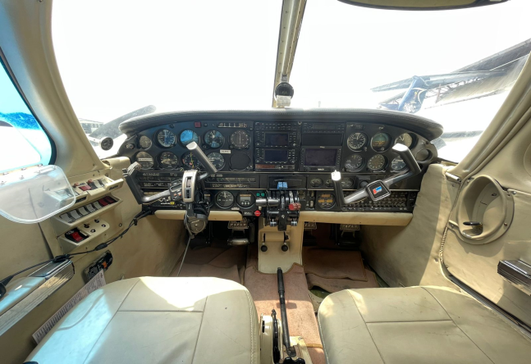

Notes:
- The aircraft complies with the standards and maintenance programs imposed by the DGAC and by the manufacturer.
- The company has its own workshop in its installation; in which the stipulated MTTO is carried out.
- Both aircraft and pilots are available 24 hours and 365 days a year.
- The company has a stock of spare parts which allows it to solve basic needs before the maintenance requirement

AVAILABLE IMMEDIATELY, MAKE OFFER

Flight Source International, Inc: +1 941-355-9585 sales@flighsource.com
Maria Eckardt WhatsApp/Cell: +1 941-586-2054 maria@flighsource.com
Samir Hiweg WhatsApp/Cell: +593 982-387-453 samir@mundiaereo.com
Samir Hiweg WhatsApp/Cell: +593 961-961-100 samir@flightsource.com

